Rotational Kinetic Energy
There are two types of speeds: linear and angular. On the left we show a mass with a linear speed ν. Its linear kinetic energy is ½mν² . In the center we show a homogeneous disk revolving about its own center. Its rotation kinetic energy is ½Iω² .
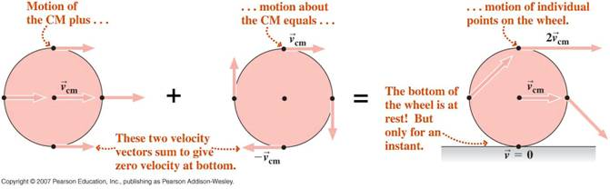
On the right we show a homogenous disk that is rolling from left to right. The disk has kinetic energy because of its linear speed ν and also has kinetic energy because of its angular speed ω.
To develop the expression for rotational kinetic energy, we consider a small bit of mass of a homogeneous cylinder that is located at a distance r from the center. The cylinder is rotating about its own center, which is not moving. The angular speed is ω. This bit of mass has linear kinetic energy because of its instantaneous linear speed.
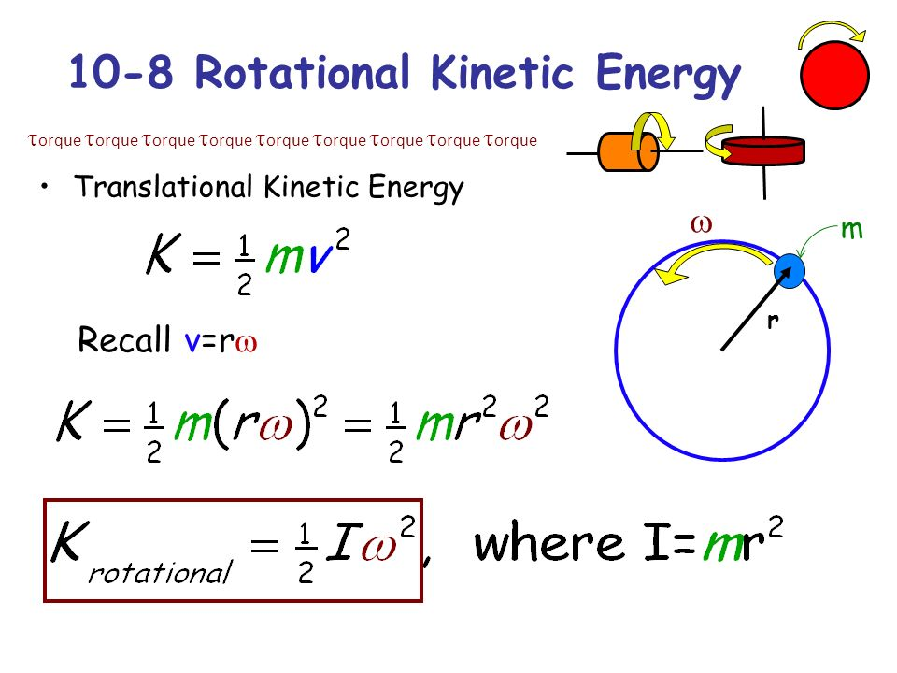
Additionally;
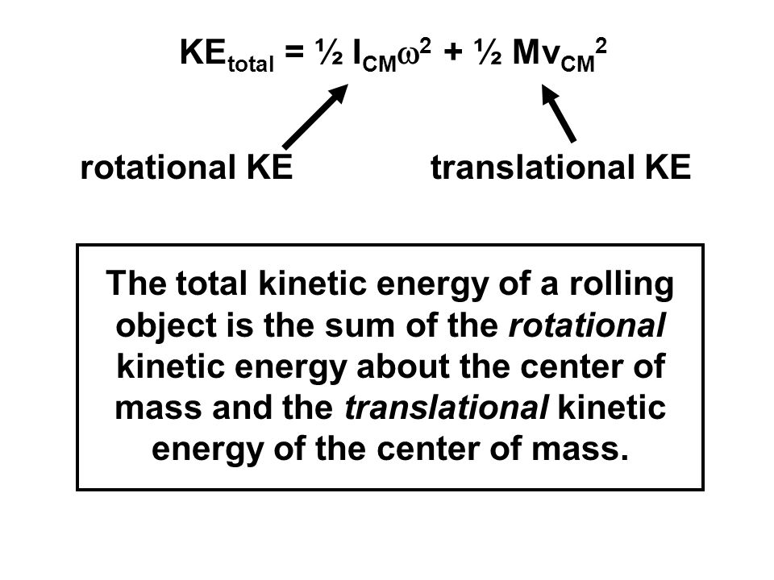
Therefore;
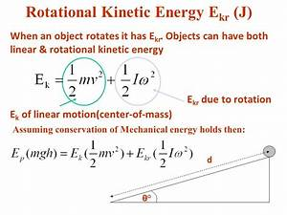

27. A homogeneous cylinder whose mass is 6 kg has a radius of 10 cm. It is revolving at 10 radians per second. What is the rotational kinetic energy of the cylinder?
(Note: I = ½ m r² ; for a cylinder.)
28. Find the total kinetic energy of a 2.0 m diameter hoop rolling, without slipping, with a speed of 4.0 m/s. The homogeneous mass of the hoop is 1.2 kg and the moment of inertia for a hoop is I = mr². (Remember ν = ω r).

29. Find the total kinetic energy of a 1.0 m diameter ball rolling, without slipping, with a speed of 10.0 m/s. The homogeneous mass of the ball is 20.0 kg and the moment of inertia for a ball is I = $\frac{2}{5}$mr². (Remember ν = ω r).

30. A homogeneous 6.25 kg cylinder, whose radius is 10.8 cm, rolls without slipping, down an inclined plane a vertical distance of 1.57 meters. What is its speed at the bottom if it starts from rest? Note: I = ½mr² for a cylinder and ν = ωr.

31. A homogeneous 5.3 kg ball rolls, without slipping, down an inclined plane, a vertical distance of 4.7 meters. What is its speed at the bottom if it starts from rest? Note: I = $\frac{2}{5}$mr² for a ball and ν = ωr.
32. Find the angular momentum of a hollow, thin sphere with a radius of 0.051 m, a mass of 0.16 kg, and an angular speed of rotation about its center of 4.2 rad/s.
(Note: angular momentum = L = Iω . and I = $\frac{2}{3}$ m r² for a hollow sphere)

33. A point mass of 0.50 kg is mounted on the end of a very light rod 2.0 meters long. It’s angular speed is 5 radians per second. What torque should be applied for 10 seconds to increase the angular speed to 20 radians per second?
Note: (Angular impulse-momentum equation: τ Δt = Δ(Iω) and I = mr² )

34. A yo-yo experiences a torque of 3.9 X 10⁻² N m as it falls for 1.3 seconds.
(a) Find the angular momentum of the yo-yo if it starts from rest.
Note: (Angular impulse-momentum equation: τ Δt = Δ(Iω) and I = mr² )

(b) If the yo-yo has a homogeneous mass of 0.20 kg, a radius of 0.030 m, and a moment of inertia of ½mr² , find its angular speed.

